**Title: Linux Command List Assessment**

**Assignment 1**

**NAME : MUTHYALA ADITYA**

**REG NO. : 20BCN7112**

**CAMPUS : VIT-AP**

**Instructions:-mv**

The following assessment aims to test your understanding and practical knowledge of various Linux commands. Perform the tasks given below using the appropriate commands. Write down the command(s) used to complete each task. You can use any Linux distribution or command-line interface of your choice. Ensure that you provide the correct output or results for each task.

**File and Directory Operations:**

ls: List files and directories



cd: Change directory



pwd: Print working directory



mkdir: Make directory



touch: Create an empty file



cp: Copy files and directories

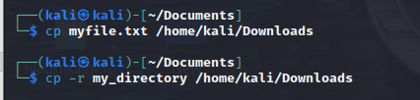

mv: Move or rename files and directories

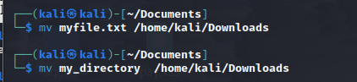

rm: Remove files and directories

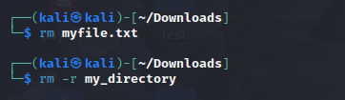

find: Search for files and directories



**File Viewing and Editing:**

cat: Concatenate and display file content





less: View file content with pagination



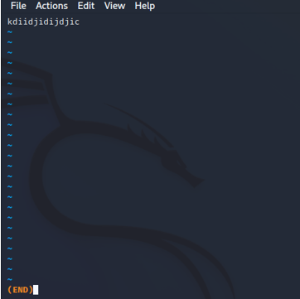

head: Display the beginning of a file





tail: Display the end of a file





nano: Text editor for creating and editing files



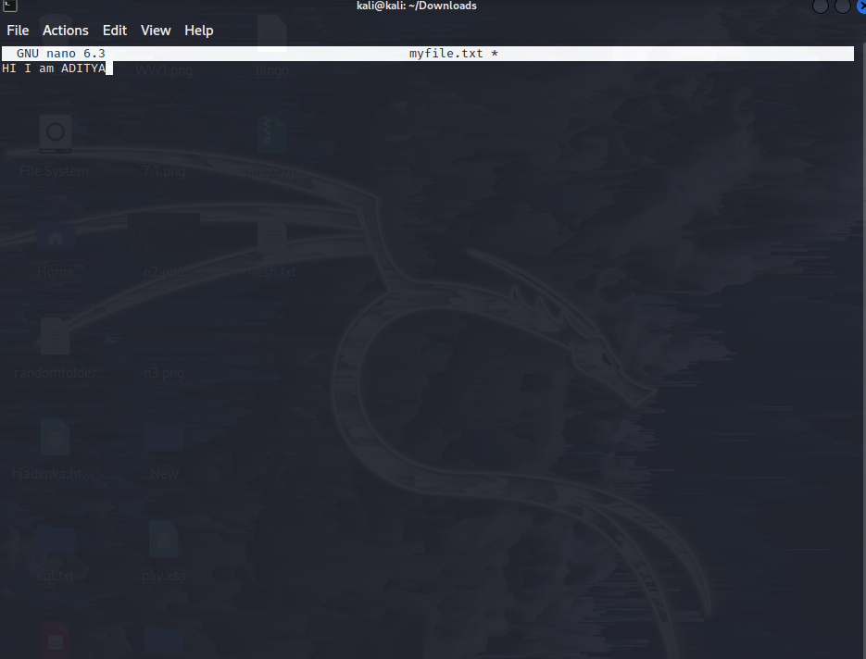

vi/vim: Powerful text editor for experienced users





**File Permissions:**

chmod: Change file permissions



chown: Change file owner



chgrp: Change file group



**File Compression and Archiving:**

tar: Archive files



gzip: Compress files



unzip: Extract files from a ZIP archive



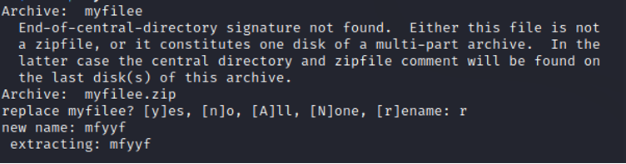

**Process Management:**

ps: List running processes

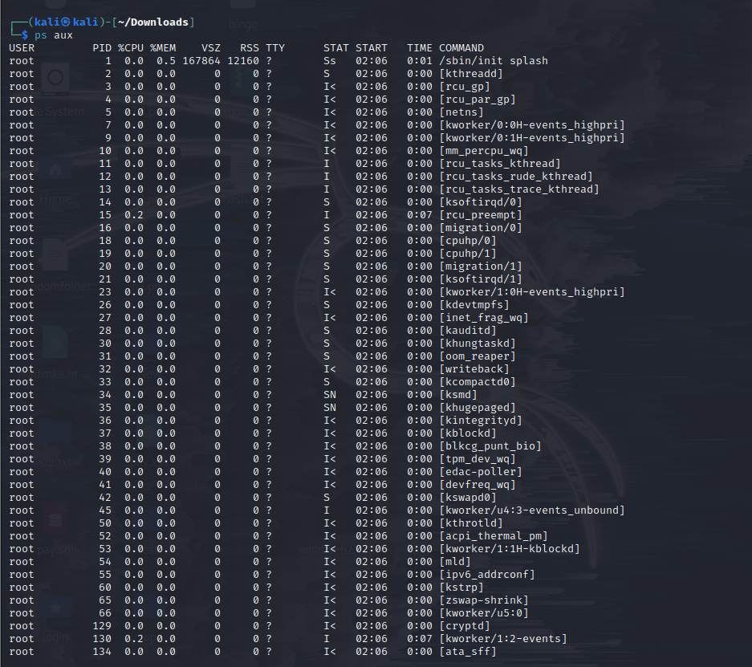

top: Display real-time system information and processes

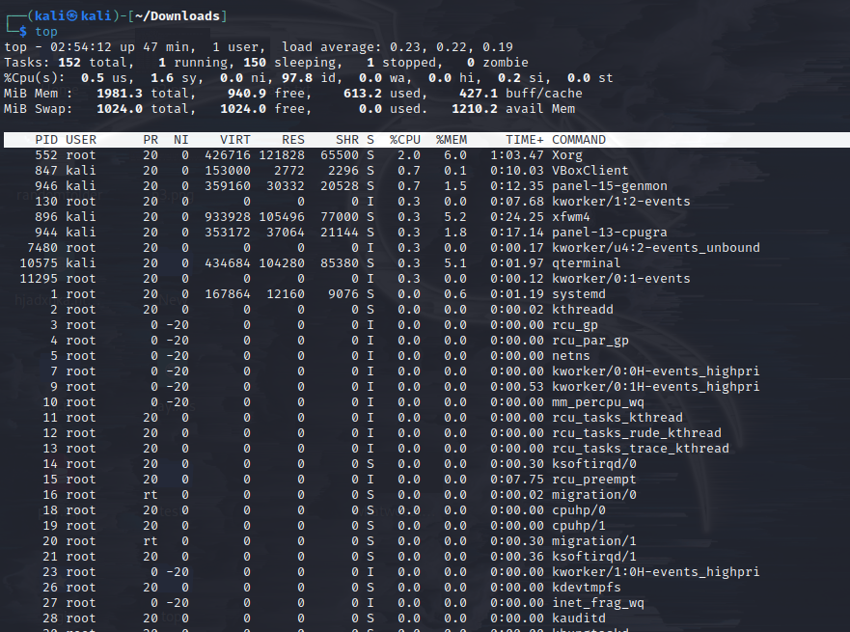

kill: Terminate processes



bg: Run processes in the background

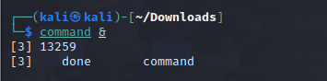

fg: Bring background processes to the foreground



**System Information:**

uname: Print system information



df: Display disk space usage

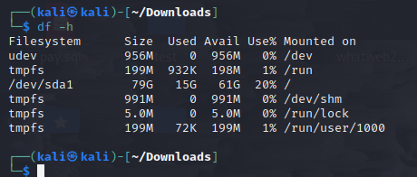

free: Display memory usage

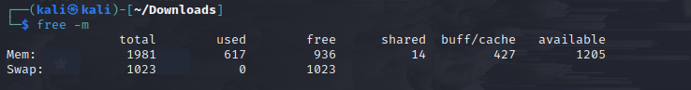

uptime: Show system uptime

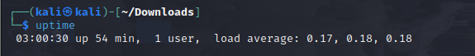

who: Display logged-in users



w: Display logged-in users and their activities

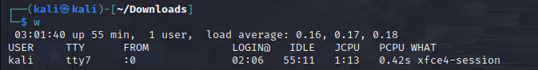

**Networking:**

ifconfig: Configure network interfaces

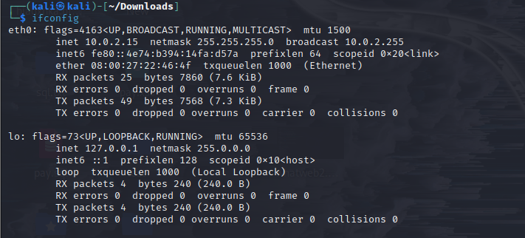

ping: Send ICMP echo requests to a network host

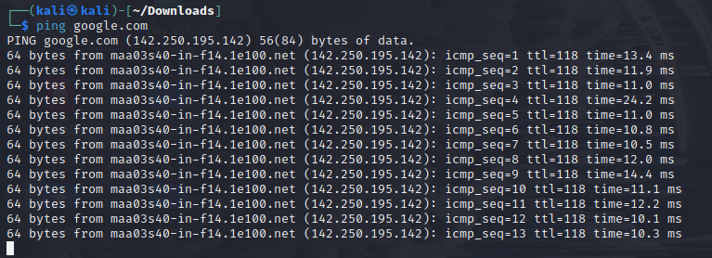

ssh: Securely connect to a remote system

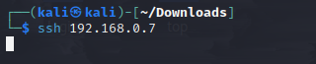

scp: Securely copy files between systems



wget: Download files from the web

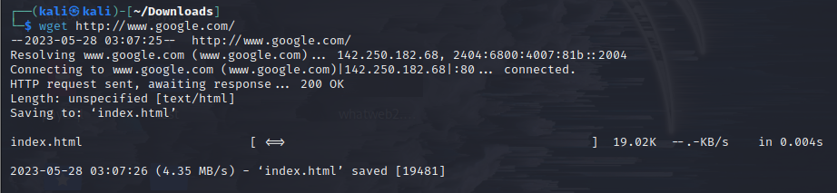

**System Administration:**

sudo: Execute commands with superuser privileges

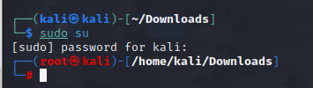

apt-get: Package management for Debian-based distributions



yum: Package management for Red Hat-based distributions

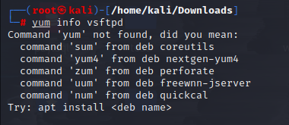

systemctl: Manage system services

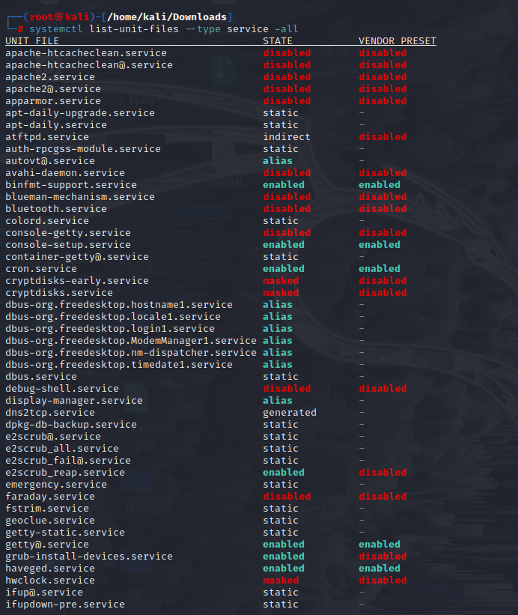

crontab: Schedule recurring tasks

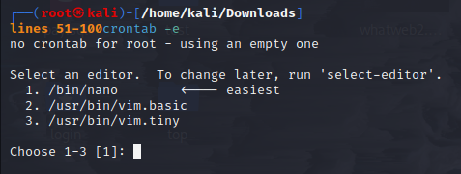

useradd: Add a new user



passwd: Change user password

